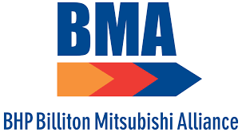 |  |  |  | Charter Flight & Accommodation Business Rules

BMA has village accommodation available in three towns for use by employees and contractors across our mine sites:
- Moranbah
- Eureka Village (BMA owned)
- Moranbah SPV (BMA owned)
- Leichhardt Village
- Buffel Park (BMA owned)
- Dysart
- Dysart SPV (BMA owned)
- Dysart Ausco
- Dysart Civeo
- Blackwater
- Ausco Blackwater
- Village on Blain
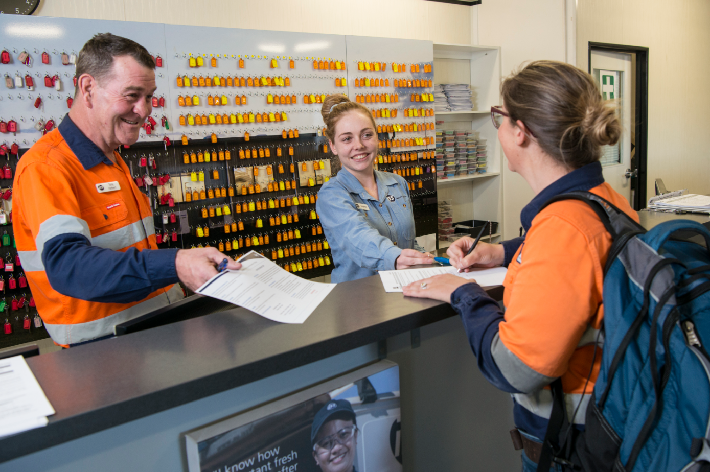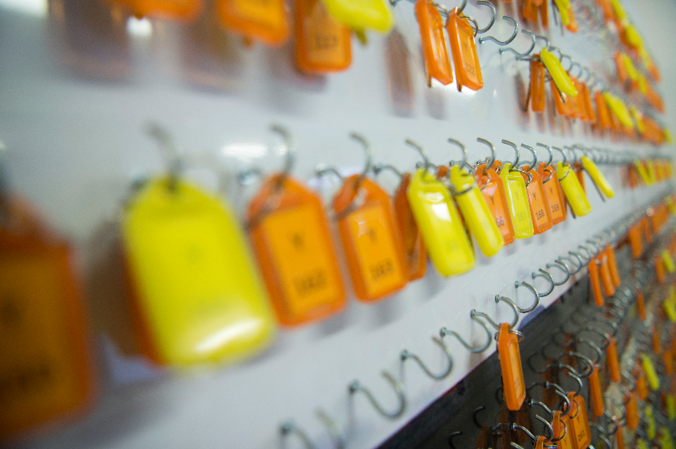
BMA Charter Flight and Accommodation Booking System
SAM is a profile-based online accommodation booking system where all users will be issued a unique profile based on their 1SAP employee number and/or LMS number.
For site-based workers, SAM will store your roster pattern to ensure your booking is never missed. Those travelling on an ad-hoc or less frequent basis will be able to make bookings via the SAM online portal.
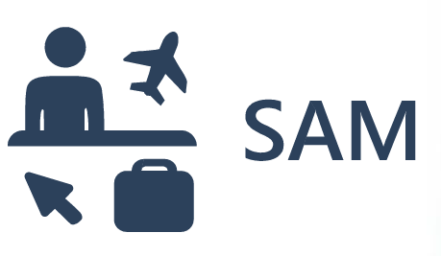
SAM is a user friendly system with self-service functionality that enables users to make bookings and then check on them in real time.
SAM's SMS functionality will allow the Brisbane Accommodation and FIFO team to contact employees and contractors directly regarding delays or cancellations or in emergency situations.
Users will receive booking confirmations via email and check their travel itineraries using the SAM app – “workforce kiosk”

How do I book my accommodation and travel with SAM?
Bookings can be completed via the SAM online portal - https://wfbma.osmotion.com.au - eliminating the need for Excel-based accommodation booking forms.

For BMA employees based permanently on site (covered by a BMA Local Accommodation Agreement or BMA Accommodation Policy) or contractors working to a permanent site roster, your bookings are already in the system. You can log into the online portal or download the SAM phone app to check that your roster pattern is correct.
For non-BMA employees, if your accommodation is usually booked by your employer, this will continue and your employer has been briefed about SAM and the changes.
Important things to remember when booking:
- You can check and/or amend your bookings at any time in the SAM portal – it’s easy to use!
- Specify in your booking request if you need a fatigue room either at the start or end of your swing.
- All charter flight and accommodation bookings must be submitted at least 48 hours prior to arrival/departure.
- If your booking is submitted within 48 hours of arrival/departure, please attach your one-up BMA line manager’s approval to the booking. Charter flights or accommodation will not be booked without BMA one-up approval.
- All personnel must have a booking prior to arriving at a BMA village. You can check the SAM app to make sure your booking has been processed.
Can I amend or make a booking using the SAM app?
No, at this point in time you can only check and track your approved bookings in the SAM app. You can download the app called “Workforce Kiosk” via the Apple Store or Google Play.
Bookings and amendments need to be made via the SAM online portal - https://wfbma.osmotion.com.au
How do I make an urgent booking or book travel and accommodation outside of business hours?
The Brisbane Accommodation and FIFO team operate during the following business hours:
Monday – Friday, 8am to 5pm (excluding Queensland Public Holidays).
For urgent bookings outside business hours, please submit a booking via the SAM portal and then call 1800 772 061 or 0408 216 179.
What are the village check-in and check-out times?
Our villages provide standard check-in and check-out times to ensure availability and cleaning of rooms:
- 2pm check-in
- 10am check-out
Check-in and check-out times do not apply to:
- Permanent room holders
- Where business provided travel (including FIFO charter flights and BMA transfer bus services) arrives prior to the 2pm check-in time.
Personnel are not encouraged to arrive at the village before 2pm as we cannot guarantee rooms will be available on your arrival.
Don’t forget to sign-in, sign-out and return your room key when you leave (even if you are a permanent room holder). During emergency events it is critical for BMA to know who is in our villages.
What if I need a fatigue room?
When you’re booking your accommodation in the SAM portal please specify in the ‘comments’ section if a fatigue room is required on the first night or last night (in some cases both). The Brisbane Accommodation and FIFO team will then update your booking accordingly.
Please book a fatigue room for the night before if you plan on arriving at the village before 2pm on your check-in day or if you need to stay past 10am on your check-out day.

What happens if I miss my charter flight or accommodation?
If you can’t make your charter flight or accommodation please let the Brisbane Accommodation and FIFO team know via the SAM portal. Bookings or amendments made within 48 hours of your arrival will need your BMA one-up line manager approval attached to the booking.
For non-permanent room holders, if you have not utilised your first night’s accommodation (no show) the room will automatically release back for allocation (unless you have nominated the first night as a fatigue room).
BMA Management teams will be reviewing monthly no show data for flights and accommodation.
What if I need to cancel my booking?
It’s easy, just go into the SAM portal and cancel your booking. Check the quick reference guides if you need help with this process.
What happens if I go on holidays?
Log into the SAM portal and submit a leave request.
Check the quick reference guides if you need help with this process.
Under this system can I arrive at a village without a booking?
Yes, however you will be subject to the village operator’s standard nightly room rate, payable upon check-in at reception. BMA does not benefit from this payment as the village operator uses this charge to cover additional unplanned costs.
If you arrive a day early the above will also apply.
SAM optimises room allocations at the villages. If you arrive without a booking, the village may not be able to accommodate your requirements due to availability.
If there is no availability within the village, you can follow the process outlined above for after-hours/emergency bookings. In the event there are no rooms available within the BMA accommodation portfolio in that township you will be required to source your own accommodation.
Please note: Moranbah and Dysart SPVs are not equipped to accept walk ins.
Personnel covered by a Local Accommodation Agreement (Moranbah, Dysart, Blackwater) will not be liable for the walk-in rate, however we ask that you keep SAM updated if you need to arrive early or leave late.
What if I’m required on site for emergency work,
do I still need to submit an accommodation request online?
Yes. We understand that personnel will be required on site for last minute emergency work, however we still need you to submit a booking request via the SAM portal. Please refer to the booking process above when submitting after hours/emergency booking.
How do I extend my stay?
If you are required to extend your stay at the village, you will need to update your booking in SAM before 10am on the original check-out date. Personnel who share a permanent room may be asked to move to another room.
If you arrive early and do not amend your booking in SAM or you stay past your last booking day, you may be required to change rooms.
Can I choose which room I go into?
No, SAM chooses your room based on availability and your planned check-in and check-out dates.
This does not apply to BMA employees with a permanent room allocation.
What is the “three strike rule”?
BMA needs to ensure that there are sufficient clean rooms available each night to accommodate all personnel. Walk-ins, no shows, early arrivals and late departures have a significant impact on our ability to allocate rooms to those who have planned their accommodation in advance.
A strike will be incurred where the booking rules referred to in this document are not followed (E.g. in the case of a walk in, no show, early arrival or late departure without a valid reason). Where three strikes are recorded, the relevant BMA Superintendent will be contacted and determine an appropriate course of action.
The three strike rule does not apply to BMA employees covered by a Local Accommodation Agreement (Moranbah, Dysart & Blackwater) or BMA Accommodation Policy.
What are the deadlines for changes to Charter Flight bookings?
Type of Request | Cut Off | Sign Off
Flight request/  cancellation/change | 48 hours prior to travel | Superintendent
New FIFO starter | 5 business days* | GM
Roster change | 3 weeks | GM
Point of origin change | 3 weeks | GM
*business day refers to Monday to Friday, excluding Queensland public holidays
What happens if I don’t have a LMS or 1SAP number for SAM?
If you are a new starter and you don’t have your LMS (SC number) or 1SAP number you will need to use your mobile number. The Brisbane Accommodation and FIFO team will be in contact with you within two weeks to verify your LMS or 1SAP number.

